1.INTRODUCTION

1.1OVERVIEW

Voyage vista: Illuminating Insights from Uber Expedtionary analysis.

Creating dashboard, story using tableau and analysing uber .

Uber is a transportation company with an app that allows passengers to hail a ride and drivers to charge fares and get paid. More specifically ,Uber is a ridesharing company that hires independent contractors as drivers.

1.2 PURPOSE

This analysis can help identify peak hours or days of high demand and optimize driver availability during those times.

2.1 EMPATHY MAP

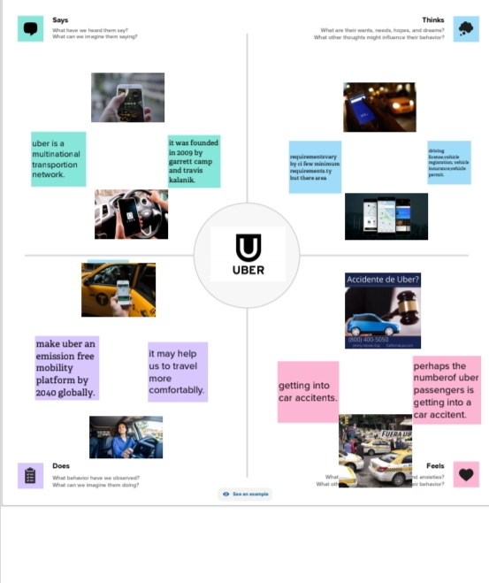

2.2 BRAINSTROMING MAP

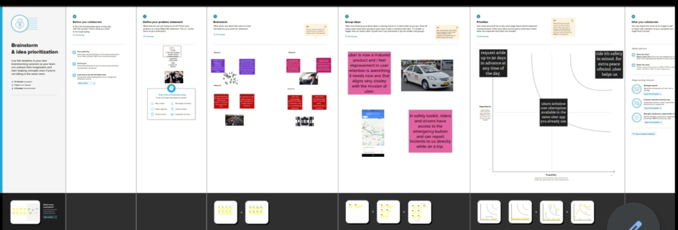

RESULT

Visualising user attitudes and behaviours in an empathy map helps team aligns on a deep understanding of end users.

1.what are the benifits of uber services?

2.what are the time efficiency of using uber?

3.how safe is riding uber?

4.what are the risks of using uber?

DASHBOARD

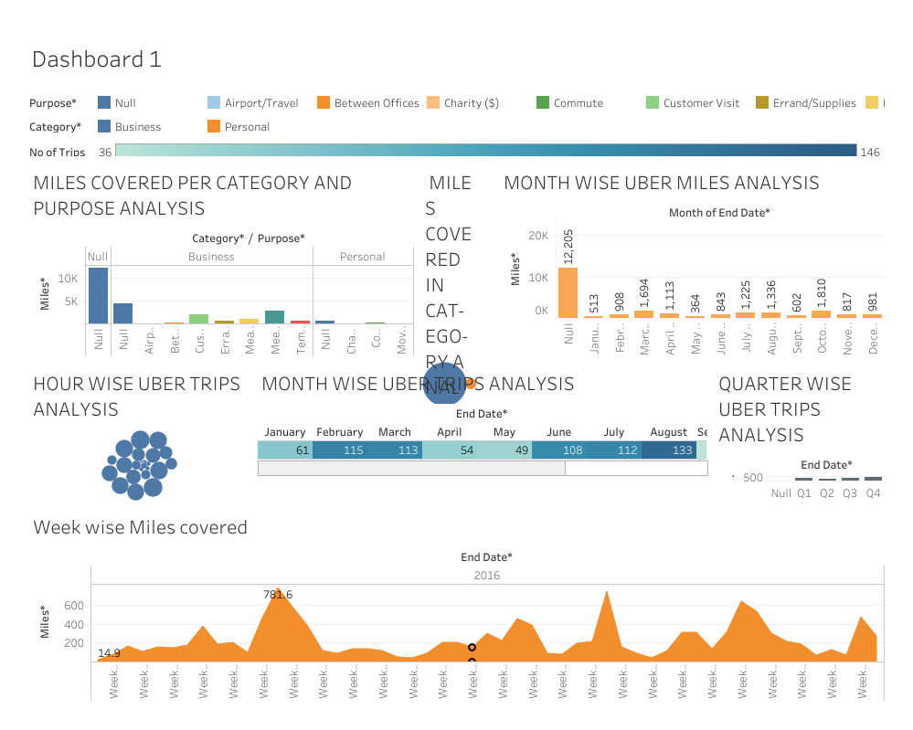

STORY

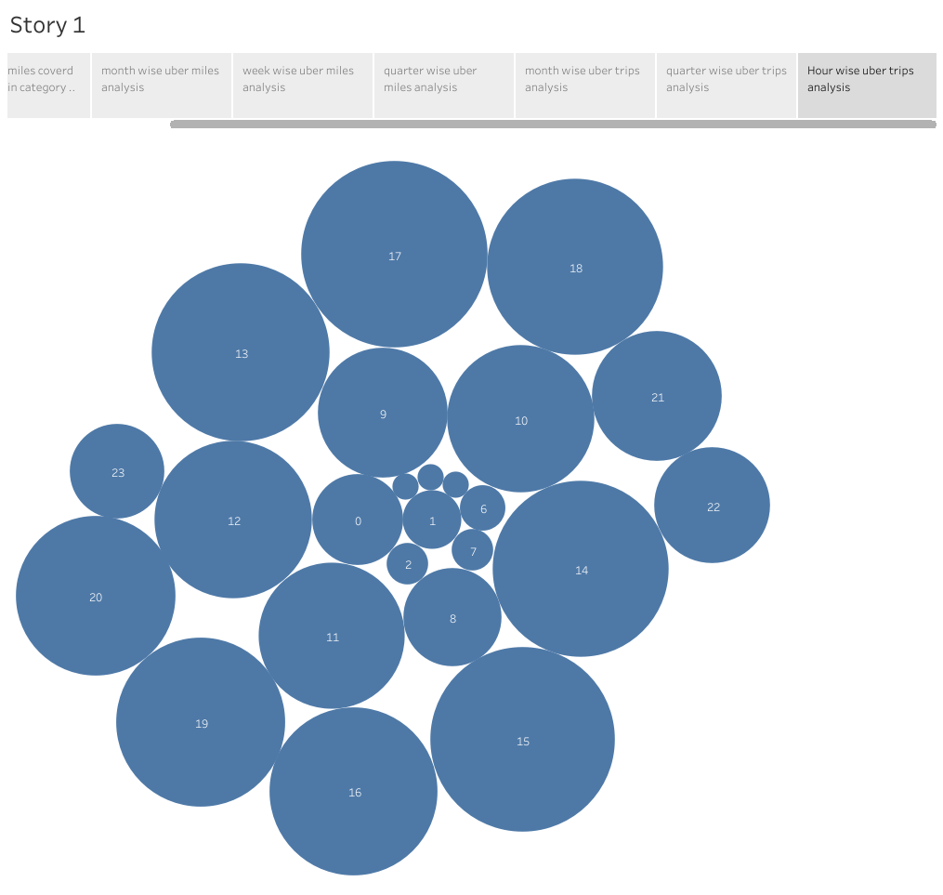

ADVANTAGES

Uber has become a prime example of the gig economy at work.

Uber's advantages include door-to-door convenience, safety, and reliable quality.

Uber's disadvantages include its surge pricing and the negative effects of replacing steady jobs with gig work.

DISADVANTAGES

* Increased competition among driver
* The need to maintain a vehicle that meets Uber's standards.
* The possibility of receiving negative reviews.
* Expenses for gas, maintenance, and insurance.
* Uncertainty about the payment rate for each ride.

APPLICATIONS

1. Uber - Driver
2. Uber Freight
3. Uber Eats
4. Uber Eats Orders
5. Uber Fleet
6. Lyft
7. Food Delivery

FUTURE SCOPE

Set up 9 years ago, the company has grown impressively and now operates in about 632 cities across 78 countries.

Having 75 million active users, Uber manages 15 million rides daily.

The company expects by 2021, around 539.49 million users will use its taxi services.